**INVENTORY CONTROL MANAGEMENT : A JAVA DESKTOP APPLICATION**

**- Kaushik D {22BCE0365}**

**ABSTRACT:**

This paper introduces a sophisticated Java-based desktop application for inventory management and sales, seamlessly integrated with a MySQL database. The system implements a robust role-based access control (RBAC) framework, defining three distinct user roles: managers, employees, and consumers. Each user role is endowed with carefully tailored permissions and functionalities, ensuring secure, efficient, and user-centric access.

Key Features:

i.) **Diverse User Roles**:

- The application caters to three distinct user roles:

- Manager

- Employee

- Consumer

ii.) **Secure Authentication**:

- User access is fortified with robust authentication mechanisms. Managers employ unique passcodes, employees are authenticated through specific username-password pairs, and consumers can access the application seamlessly.

iii.) **Role-Based Permissions**:

- Users are granted role-specific privileges and access rights, finely tuned to their responsibilities.

iv.) **Managerial Contro**l:

- Managers exercise comprehensive authority over both employee data and product information within the database. They can create, read, update, and delete records, including user accounts and product listings.

v.) **Employee Empowerment**:

- Employees are empowered to manage the product database. They can view product listings, introduce new products, edit existing entries, and remove products when necessary.

vi.) **User-Friendly Consumer Access**:

- Consumers enjoy a frictionless entry into the application, devoid of passcodes. They can effortlessly explore product listings, place orders, and complete payment transactions at the point of sale.

vii.) **Streamlined Functionality**:

- The application offers core functionalities, thoughtfully designed to meet the distinct needs and responsibilities of managers, employees, and consumers.

In addition to the core features, the application boasts a meticulously crafted user interface (UI) utilizing Java Swing, providing a polished, intuitive, and user-friendly experience. Furthermore, it incorporates an audit logging system to meticulously record all database changes, enhancing transparency and accountability. To cater to diverse global markets, the application supports multiple currencies and languages.

This comprehensive solution is designed to streamline inventory management and sales operations, delivering a secure, efficient, and user-centric experience to managers, employees, and consumers. Its seamless integration with the MySQL database, unwavering commitment to security, user satisfaction, and global adaptability make it an indispensable tool for modern businesses seeking effective inventory management and sales operations.

**FLOW-CHART:**

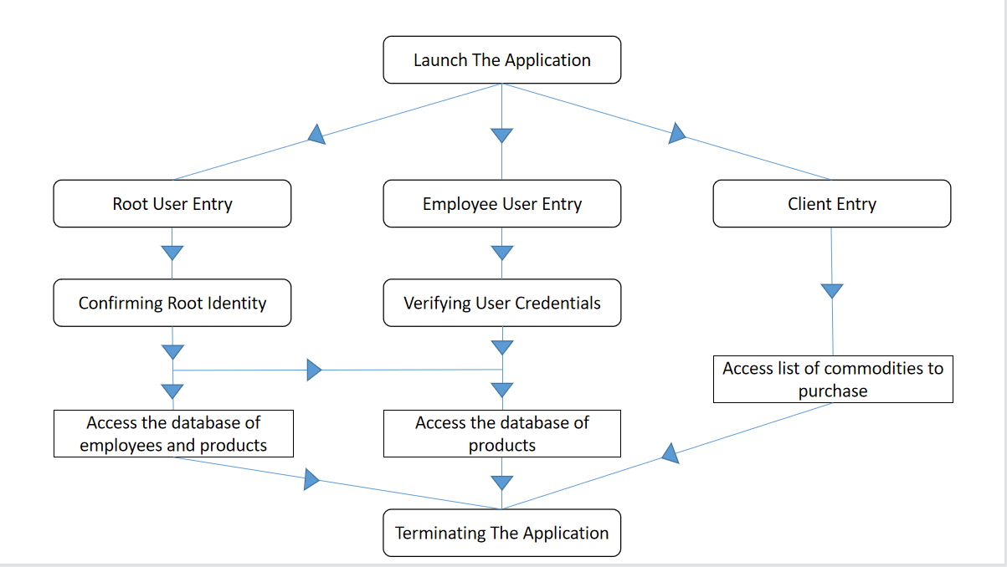

**MySQL DATABASE:**

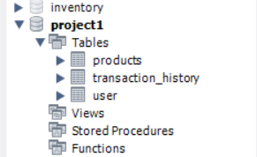

**PRODUCT DATABASE:**

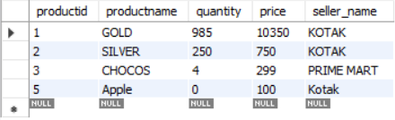

**EMPLOYEE DATABASE:**

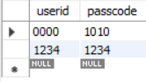

**Execution of Application:** {Screenshots}

**ADMIN**

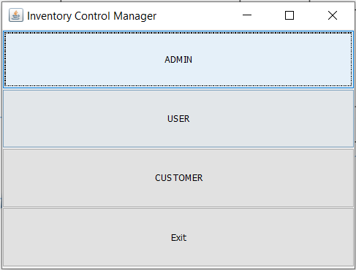

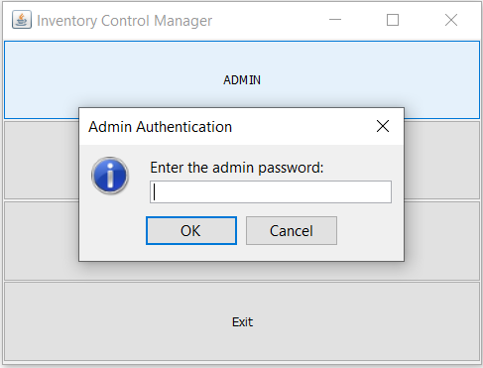

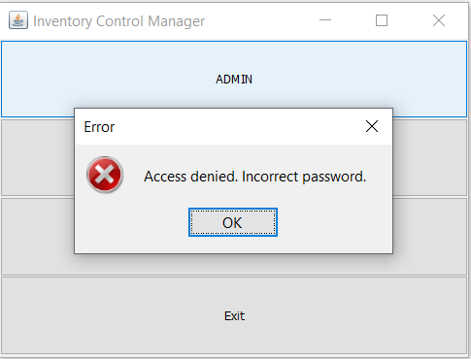 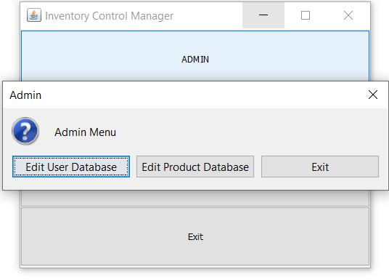

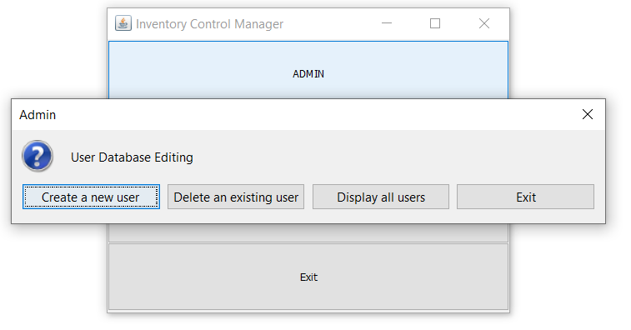

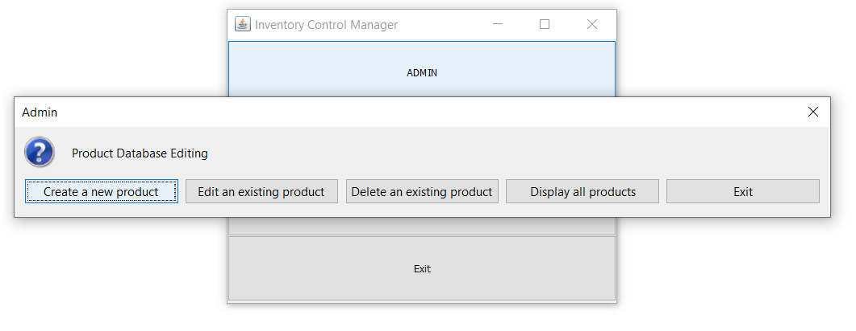

**EMPLOYEE**

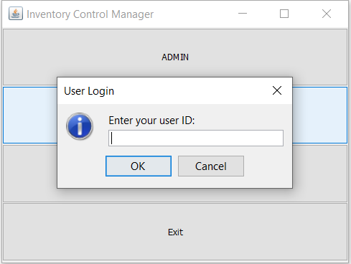

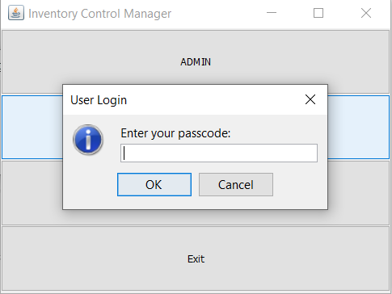

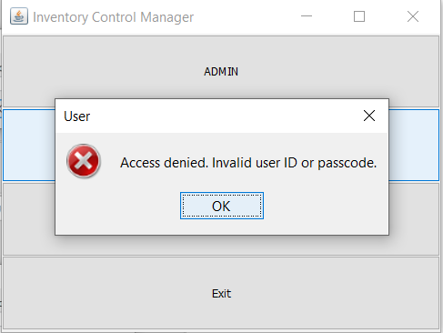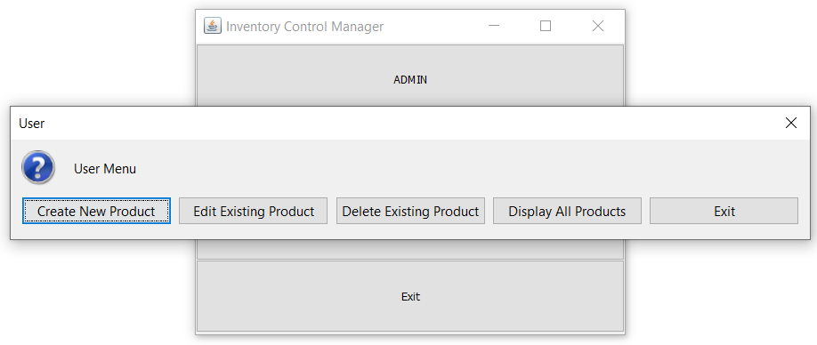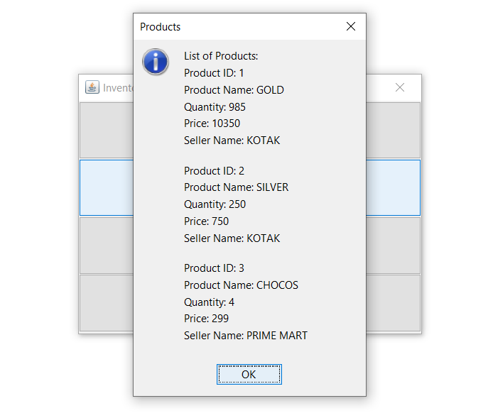

**Creating and Editing Products**

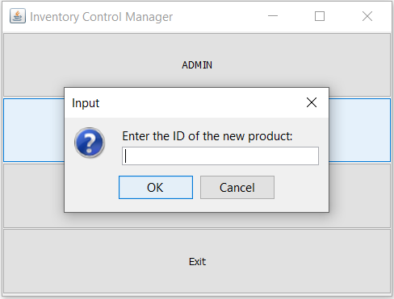

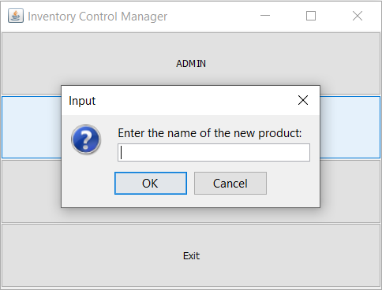

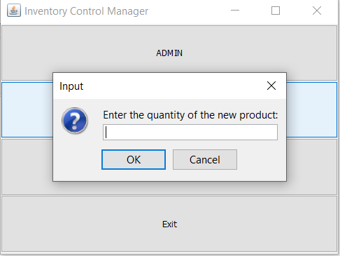

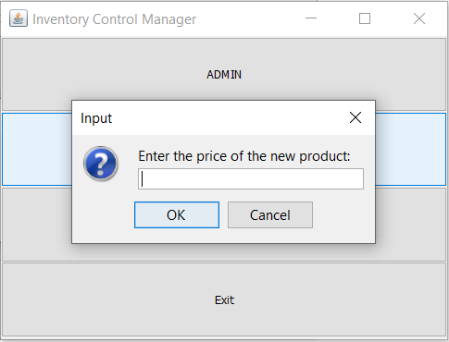

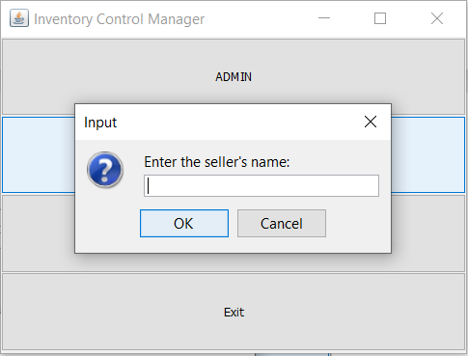

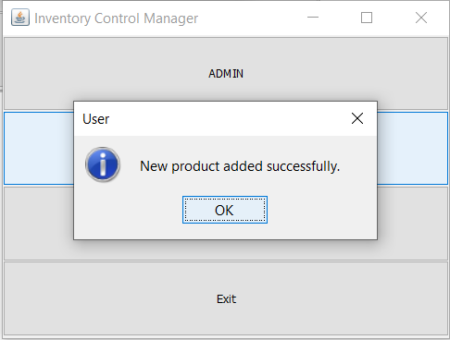

{ CREATING A PRODUCT; ID : 5, NAME:APPLE, QUANTITY : 10, PRICE:100, SELLER’S NAME: KOTAK}

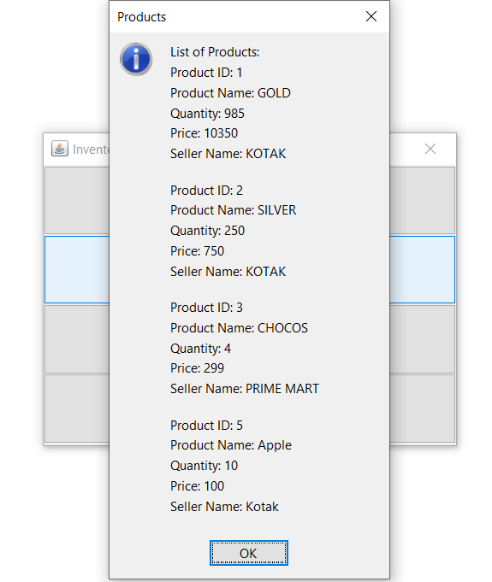

{ HERE, WE CAN SEE THAT THE PRODUCT HAS BEEN ADDED}

**CUSTOMER**

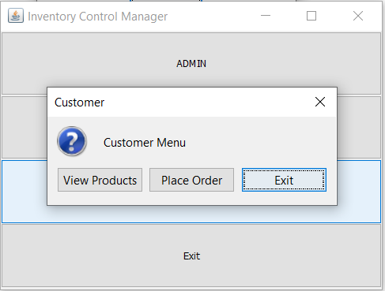

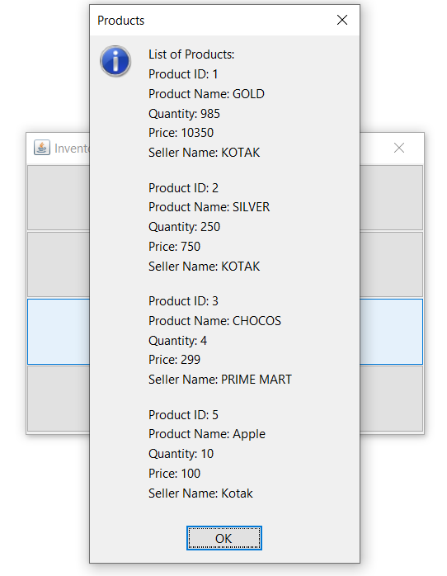

{ PLACING AN ORDER }

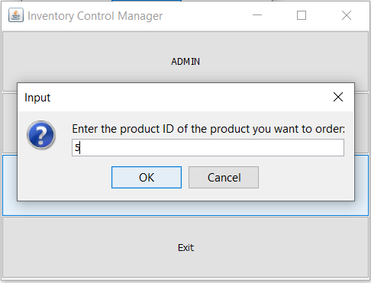

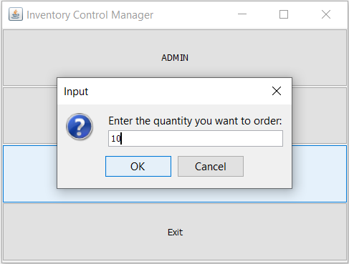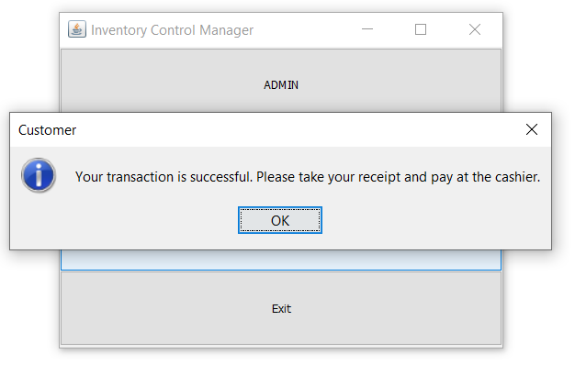

{ HERE WE CAN SEE THE QUANTITY DECREASE }

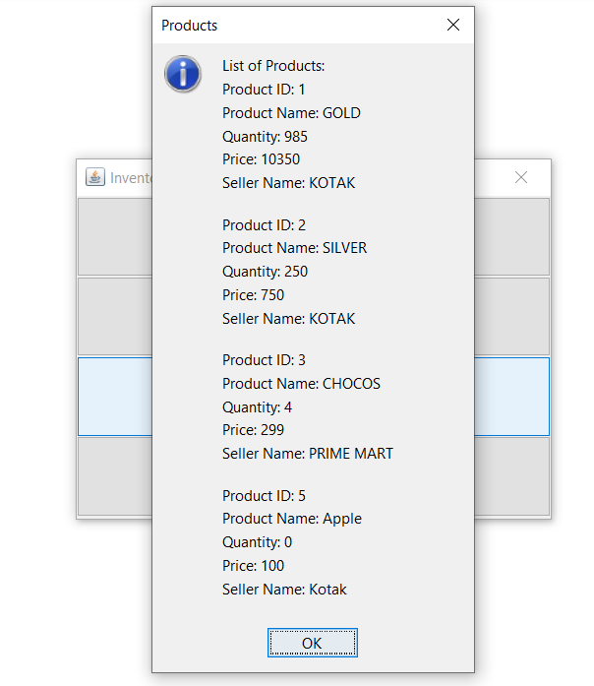

{ IF THE REQUIRED QUANTITY IS MORE THAN THE QUANTITY IN STOCK, WE GET THIS }

